Nottingham Little League
Summer 2020 Season

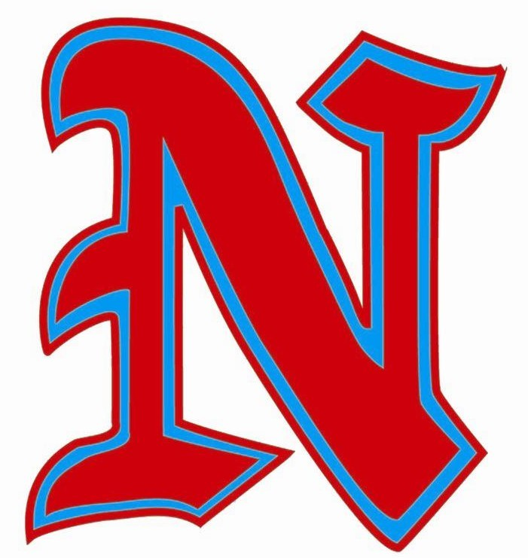

Program Preparation Plan

Table of Contents

1. Guidelines for Participating in the Summer 2020 Season 3
2. Guidelines for the Use of NLL Facilities: 3
2.1. Indoor Cages: 3
2.2. Bathrooms: 3
2.3. Hygiene: 3
2.4. Concession Stand: 3
2.5. Press Boxes: 4
3. Guidelines for Practices or Games: 4
3.1. Coaches: 4
3.2. Players: 5
3.3. Spectators: 5
4. Guidelines for Games Only 6
4.1. Scheduling: 6
4.2. Pregame 6
4.3. Baseballs 6
4.4. During the Game: 6
4.5. End of the Game: 7
5. Guidelines for Handling a Positive COVID-19 Test 7

Nottingham Little League (NLL) has prepared the following guidelines for the Summer 2020 Season based on the requirements provided by the New Jersey Department of Health. All players, coaches, staff, spectators and any other attendees at the NLL facility must adhere to these guidelines.

Guidelines for Participating in the Summer 2020 Season
Anyone who is not comfortable participating in the Summer 2020 Season, or who does not feel comfortable following these guidelines, should not return for this season.

ALL players, coaches and staff will be required to sign a waiver before being allowed to participate in any practice/game. Managers will be responsible to collect all waivers and give to their VP’s. Waiver will be posted to NLL website by Tuesday, June 23.

Guidelines for the Use of NLL Facilities:

Indoor Cages:
The indoor cages will be closed to practices and pregame warmups.

Bathrooms:
- Bathrooms will be open during games only and will be disinfected after games.
- Only one person will be allowed in a bathroom at one time—bathroom doors will be left open.
- People waiting in line for the bathroom should ensure social distancing with people other than their immediate family.

Hygiene:
- All players, coaches, umpires and spectators should practice “good hygiene” by regularly washing their hands with soap and water or using hand sanitizer that contains at least 60% alcohol (will be supplied to all players, coaches).
- Avoid touching your eyes, nose and mouth. Players and coaches should avoid all but the essential contact necessary during practice or competition.
- All players, coaches, spectators and umpires must bring their own food or beverages that are clearly labeled with their name. Sharing of food or beverages is not allowed.
- The following are not permitted:
  - Sunflower seeds,
  - Chewing Gum,
  - All players and coaches are encouraged to refrain from spitting.

Concession Stand:
- The NLL concession stand will be open with limited availability this year.
  - Only the Candy/Ice Cream window will be open Monday- Friday.
  - There will be limited prepackaged items and beverages available.
  - There will be NO parent volunteers assisting in the kitchen this year. Instead, operations will be ran solely by our amazing NLL Auxiliary members. Staff will maintain social distancing, wear masks and gloves and utilize all other safety measures possible to keep our members and customers as safe as possible.
- NLL has also invited several local food trucks to park on site during the week to offer our league some hot food options while at the field.
  - Trucks will be on site Monday, Tuesday, Wednesday (only in July) and Friday evenings.
- On evenings when there are only two games being played, the NLL Auxiliary will have a table set up with a hot food option to purchase.

Press Boxes:
- All press boxes will remain locked at all times.
- The Home team may appoint 1 adult to run the scoreboard during games.
  - Appointed adults must use hand sanitizer before and after games.
  - Press box doors must remain closed and locked while adult is inside running the scoreboard.
- Umpires can be provided access to the Reed clubhouse by the OD or board member.

Guidelines for Practices or Games:

Coaches:
- All coaches must wear a mask during practices and games when not able to maintain social distance guidelines.
- Upon arrival for each practice or game, each player will be required to have a temperature check by a person who is designated by the manager (coach, father rep, mother rep). A parent or guardian will need to be present to answer the following questions:
  - Have you had a fever today?
  - Have you had a cough today that isn’t explainable by another condition (such as allergies)?
  - Do you feel sick or achy?
  - Has anyone in your house been sick lately?
Anyone with a fever or answers Yes to any of the above cannot participate and should not attend a practice or game until evaluated by a medical provider and given clearance to do so
- If a coach is informed about a player who has vacationed, or plans to, out of state the manager will inform the division VP. The league will review state guidelines and inform the family and manager of eligibility and when, if quarantine is required, the player can return to play.
- Coaches are responsible for ensuring social distancing between players as much as possible, such as:
  - Additional spacing between players while playing catch.
  - Changing drills so that players remained spaced out during warmups/drills.
  - No congregating of players while waiting to bat.
- Coaches are responsible for disinfecting shared equipment, such as catcher’s equipment, after each game and practice or prior to providing to a new player.
  - NLL will provide teams with disinfecting wipes. Additional wipes will be available in the concession stand.
- After each game, the Away team coaches are responsible for spraying down both dugouts with disinfecting solution (this includes commonly touched areas such as fences, bat and helmet racks, and benches as well as the folding chairs before putting them away). Solution should be left to dry on its’ own.
  - Disinfecting Solution sprays can be found in both the Gallagher and Tola sheds. Additional solution is available in the Gallagher shed.

Players:
- All players need to use their own baseball equipment (gloves, helmets, and bats).
- Players must bring their own water/beverage to consume. No shared fountains or coolers.
- Players do not need to wear a face covering while on the field.
  - Players are permitted to wear a face-covering at any time if the player or their parent/guardian/caretaker deem it necessary.

Spectators:
- Spectators shall ensure social distancing with people other than their immediate family. They must also:
  - Stay six feet away from individuals outside their household.
  - Wear a cloth face covering when not able to maintain social distance guidelines.
  - Avoid direct hand or other contact with the players, managers, and coaches during play.
- Spectators should bring their own seating or portable chairs when possible.
- A spectator with any of the following conditions should not attend a practice or game until evaluated by a medical provider and given clearance to do so:
  - Active COVID-19 infection
  - Known direct contact with an individual testing positive for COVID-19
  - Fever
  - Cough
- Those at higher risk for severe disease should consider consulting with their medical provider before attending a game and should ensure the strictest adherence to guidelines regarding face coverings, distancing, and handwashing. Such groups include:
  - Those with a serious underlying medical condition, including heart disease, morbid obesity, diabetes, lung disease, immunocompromised, chronic kidney disease, and chronic lung disease.
  - Those currently residing in a nursing home or long-term care facility
  - Those over 65.

Guidelines for Games Only

Scheduling:
- No more than 2 games will be scheduled at the NLL facility at the same time.
- Game times will be spaced out to allow for teams to finish their game and leave the facility before other teams show up to play.
- A 2-hour drop-dead time will be employed for all games.

Pregame
- Players should not arrive more than 40 minutes before game time. Anyone arriving earlier than 40 minutes must remain in their car.
- Warm-ups should be limited as much as is reasonable.
  - Congregating players in the outfield to field grounders or pop-ups is prohibited.
  - Pitchers should be allowed to warm up with a catcher before each game.
  - Batting practice is prohibited.

Baseballs
- Each team should use their own balls while in the field during games.
- Each team must have minimum 3 baseballs per game.
- Foul balls landing outside the field of play should be retrieved by participating players and coaches. No spectators should retrieve the ball.

During the Game:
- Coaches
  - Coaches must call the umpire to their dugout with any questions and remain 6ft away. For the safety of all we will not allow aggressive arguing with any umpire.
  - Coaches must refrain from celebratory physical contact and discourage players from doing the same.
- Players
  - Players must maintain social distancing guidelines when not actively involved (including in the dugout).
  - Hand sanitizer must be used before and after entering the field of play.
- Umpires
  - Umpires need to wear masks.
  - Umpires will call balls and strikes from behind the pitcher.

End of the Game:
- There can be no handshakes or fist bumps before or after the games. Please tip your hat to the opponents after the game.
- There will be no post game meetings between the coaches and players. Any follow up can be done via email.
- Players and their families are expected to be cleaned up and leave the facility immediately after the game. No post game gatherings will be allowed.
- Trash must be discarded in a waste receptacle.

Guidelines for Handling a Positive COVID-19 Test
If a player or coach tests positive for COVID-19 or comes in direct contact with an outside person who tests positive for COVID-19, the league will take the following steps.
- The activities for that team affected by a positive COVID-19 test will be suspended immediately.
- The league will contact the Hamilton Township Health officials for guidance and follow all their recommendations.

